Jira Lab Assignment 9

Harsh Rakeshkumar Bhatt

Project Management, Conestoga College

MGMT8750: Agile Project Management

Professor Shams Salim

August 01, 2023

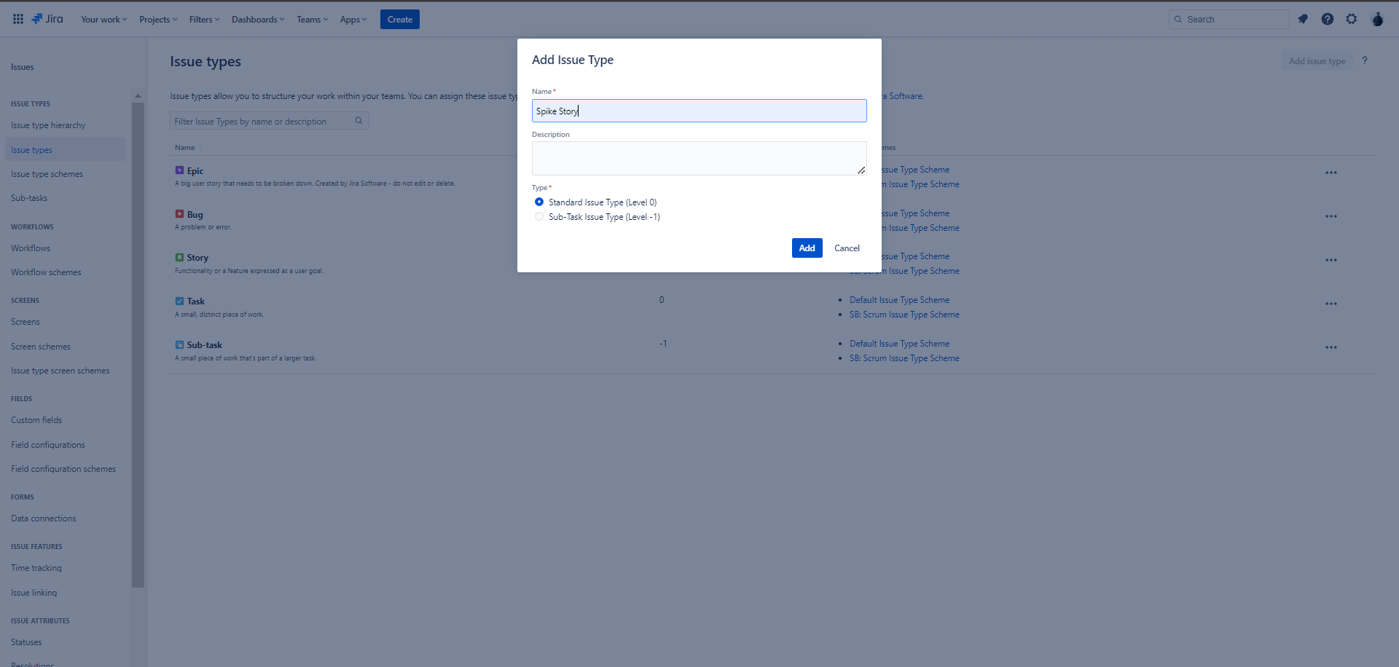
Screenshot 1

Screenshot 2
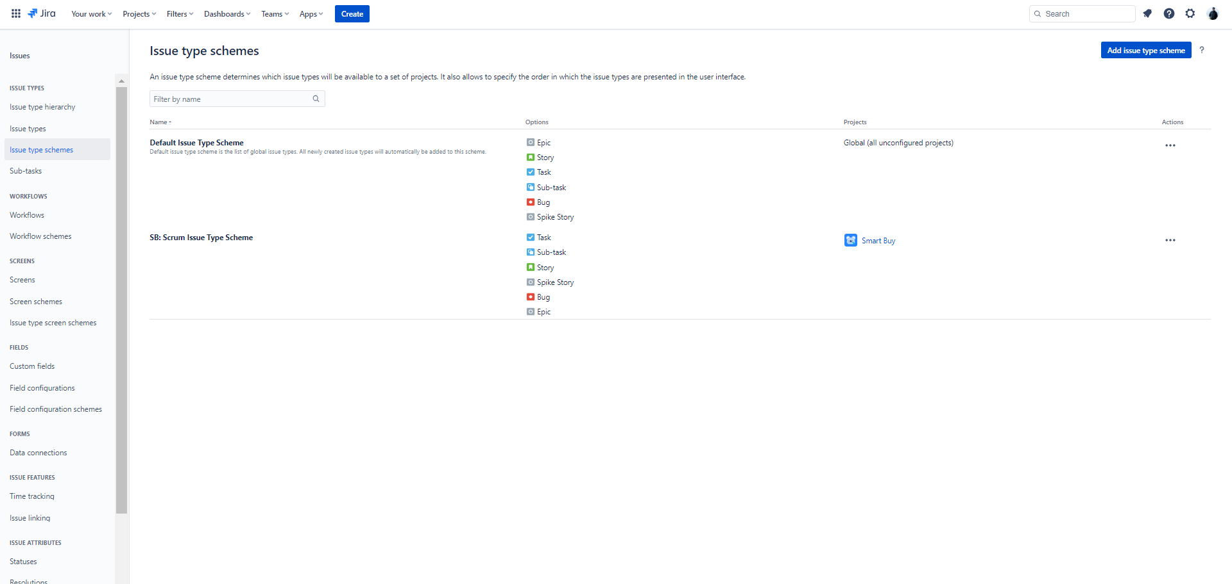

Screenshot 3
